 | 10.1.13 Editors - Compositor Editor - Header - Add Menu - Texture
Table of content
Detailed table of content 1
Add menu - Texture 5
Brick Texture 5
Checker Texture 6
Gabor Texture 7
Gradient Texture 8
Magic Texture 9
Noise Texture 10
Voronoi Texture 12
Wave Texture 15
White Noise Texture 16

Detailed table of content
Detailed table of content
Detailed table of content 1
Add menu - Texture 5
Brick Texture 5
Inputs 5
Color 1, Color 2 and Mortar 5
Scale 5
Mortar Size 5
Mortar Smooth 5
Bias 5
Brick Width 5
Row Height 5
Properties 5
Offset 5
Frequency 6
Squash 6
Frequency 6
Outputs 6
Color 6
Factor 6
Checker Texture 6
Inputs 6
Vector 6
Color1, Color 2 6
Scale 6
Outputs 6
Color 6
Factor 6
Gabor Texture 7
Inputs 7
Vector 7
Scale 7
Frequency 7
Anisotropic 7
Orientation 7
Properties 7
Type 7
Outputs 7
Value 7
Phase 7
Intensity 7
Gradient Texture 8
Inputs 8
Vector 8
Properties 8
Gradient Type 8
Linear 8
Quadratic 8
Easing 8
Diagonal 8
Spherical 8
Quadratic Sphere 8
Radial 8
Outputs 8
Color 8
Factor 9
Magic Texture 9
Inputs 9
Vector 9
Scale 9
Distortion 9
Properties 9
Depth 9
Outputs 9
Color 9
Factor 9
Noise Texture 10
Inputs 10
Vector 10
Normalize 10
W 10
Scale 10
Detail 10
Roughness 10
Lacunarity 10
Offset 10
Gain 11
Distortion 11
Properties 11
Dimensions 11
1D 11
2D 11
3D 11
4D 11
Type 11
Multifractal 11
Ridged Multifractal 11
Hybrid Multifractal 11
fBM (fractal Brownian Motion) 11
Hetero Terrain (Heterogeneous Terrain) 11
Outputs 12
Factor 12
Color 12
Voronoi Texture 12
Inputs 12
Normalize 12
Vector 12
W 13
Scale 13
Detail 13
Roughness 13
Lacunarity 13
Smoothness 13
Randomness 13
Properties 13
Dimensions 13
1D 13
2D 13
3D 13
4D 13
Feature Output 13
F1 13
Smooth F1 14
Distance To Edge 14
N-Sphere Radius 14
Distance Metric 14
Euclidean 14
Manhattan 14
Chebychev 14
Minkowski 14
Outputs 14
Distance 14
Color 14
Position 14
W 14
Radius 14
Wave Texture 15
Inputs 15
Vector 15
Scale 15
Distortion 15
Detail 15
Detail Scale 15
Detail Roughness 15
Phase Offset 15
Properties 15
Wave Type 15
Bands direction 16
Wave Profile 16
Saw 16
Sine 16
Triangle 16
Outputs 16
Color 16
Factor 16
White Noise Texture 16
Inputs 16
Vector 16
W 16
Properties 17
Dimensions 17
1D 17
2D 17
3D 17
4D 17
Outputs 17
Value 17

Add menu - Texture

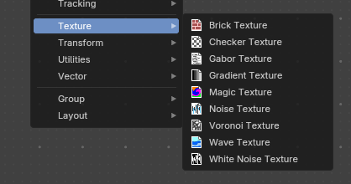
Here are the texture nodes. They allow you to add different texture types to the scene.
These should be identical to the texture nodes you can access in the Shader Editor.

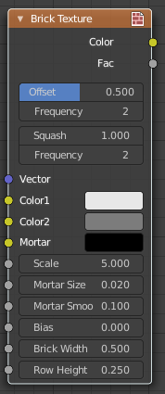
Brick Texture
The Brick Texture node is used to add a procedural brick texture.

Inputs

Color 1, Color 2 and Mortar
Color of the bricks and mortar.

Scale
Overall texture scale.

Mortar Size
The size of the filling between the bricks known as “mortar”; 0 means no mortar.

Mortar Smooth
Blurs/softens the edge between the mortar and the bricks. This can be useful with a texture and displacement textures.

Bias
The color variation between Color 1/2. Values of -1 and 1 only use one of the two colors; values in between mix the colors.

Brick Width
The width of the bricks.

Row Height
The height of the brick rows.

Properties

Offset
Determines the brick offset of the various rows.

Frequency
Determines the offset frequency. A value of 2 gives an even/uneven pattern of rows.

Squash
Amount of brick squashing.

Frequency
Brick squashing frequency.

Outputs

Color
Texture color output.

Factor
Mortar mask (1 = mortar).

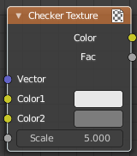
Checker Texture
The Checker Texture node adds a procedural checkerboard texture.

Inputs

Vector
Texture coordinate to sample texture at; defaults to Generated texture coordinates if the socket is left unconnected.

Color1, Color 2
Color of the checkers.

Scale
Overall texture scale. The scale is a factor of the bounding box of the face divided by the scale. For example, a scale of 15 will result in 15 alternate patterns over the overall UV bounding box. Different patterns could be achieved using other nodes to give different input patterns to this socket. For example, using the Math Node.

Outputs

Color
Texture color output.

Factor
Checker 1 mask (1 = Checker 1).

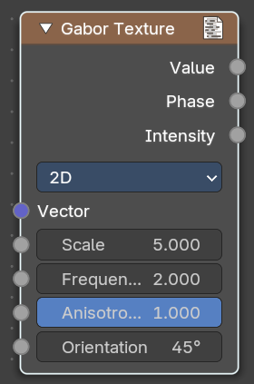
Gabor Texture
The Gabor Texture is a special directional noise texture from the OSL Shading language.

Inputs

Vector
Texture coordinate to sample texture at defaults to Generated texture coordinates if the socket is left unconnected.

Scale
The scale of the Gabor noise.

Frequency
The rate at which the Gabor noise changes across space. It differs from the input scale in that it only scales perpendicular to the gabor noise direction.

Anisotropic
The directionality of the Gabor noise. 1 means the noise is completely directional. With a value of 0 the noise goes in all directions.

Orientation
The direction of the anisotropic Gabor noise. With the 2ds method you have a orientation value. With the 3d method you will have a trackball to adjust the orientation.

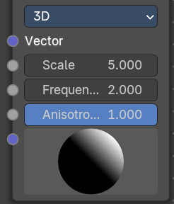
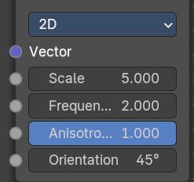
Properties

Type
2D ignores the Z input. 3D goes in all 3 directions.

Outputs

Value
The Gabor noise value with both, random phase and random intensity.

Phase
The phase of the Gabor noise, without random intensity.

Intensity
The intensity of the Gabor noise, withbout random phase.

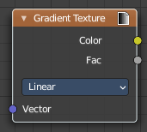
Gradient Texture
The Gradient Texture node generates interpolated color and intensity values based on the input vector.

Inputs

Vector
Texture coordinate to sample texture at; defaults to Generated texture coordinates if the socket is left unconnected.

Properties

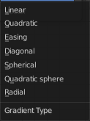
Gradient Type
Controls the type of gradient generated.

Linear
Directly returns the input X coordinate.

Quadratic
Interpolates the input X coordinate quadratically.

Easing
Uses a combination of quadratic and linear interpolation to return a smooth gradient from the input X coordinate.

Diagonal
Averages the input X and Y coordinates.

Spherical
Creates an inverse gradient using the length of the input vector; the maximum value is at (0, 0, 0).

Quadratic Sphere
The same as Spherical, except interpolated quadratically.

Radial
Returns a value based on the angle of the input around the Z axis.

Outputs

Color
Texture color output.

Factor
Texture intensity output.

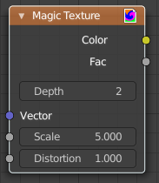
Magic Texture
The Magic Texture node is used to add a procedural psychedelic color texture.

Inputs

Vector
Texture coordinate to sample texture at; defaults to Generated texture coordinates if the socket is left unconnected.

Scale
Scale of the texture.

Distortion
Amount of distortion.

Properties

Depth
Number of iterations.

Outputs

Color
Texture color output.

Factor
Texture intensity output.

Noise Texture
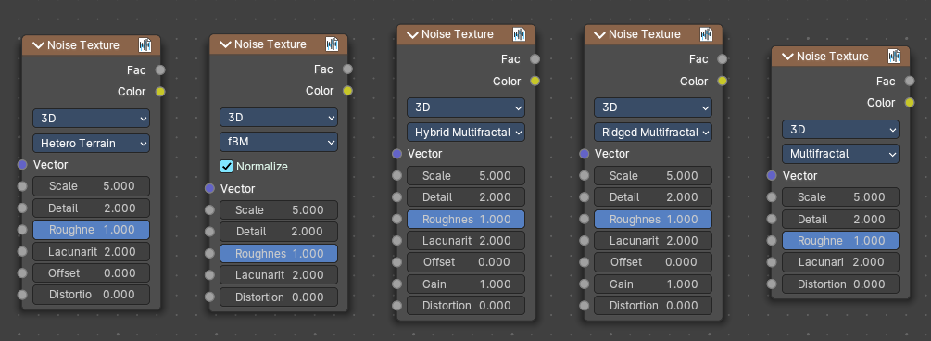
The Noise Texture node evaluates a fractal Perlin noise at the input texture coordinates. This nodes allows great control over how noise octaves are combined.

Inputs
The inputs are dynamic, they become available if needed depending on the node properties.

Vector
Texture coordinate to evaluate the noise at; defaults to Generated texture coordinates if the socket is left unconnected.

Normalize
Normalize the output to the 0 - 1 range.

W
Texture coordinate to evaluate the noise at. Appears with 4 dimensions.

Scale
Scale of the base noise octave.

Detail
Number of noise octaves. The fractional part of the input is multiplied by the magnitude of the highest octave. Higher number of octaves corresponds to a higher render time.

Roughness
Adds a roughness noise.

Lacunarity
The scale of a perlin noise octave relative to the perlin noise octave from the previous octave.

Offset
An added offset to each octave, determines the level where the highest octave will appear.

Gain
An extra multiplier to tune the magnitude of octaves.

Distortion
Amount of distortion.

Properties

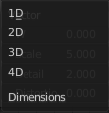
Dimensions
The dimensions of the space to evaluate the noise in.

1D
Evaluate the noise in 1D space at the input W.

2D
Evaluate the noise in 2D space at the input Vector. The Z component is ignored.

3D
Evaluate the noise in 3D space at the input Vector.

4D
Evaluate the noise in 4D space at the input Vector and the input W as the fourth dimension.

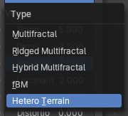
Type
Type of the perlin noise texture.

Multifractal
The result is more uneven (varies with location), more similar to a real terrain. Uses a multiplicative cascade.

Ridged Multifractal
Creates sharp peaks. Calculates the absolute value of the noise, creating “canyons”, and then flips the surface upside down.

Hybrid Multifractal
Creates peaks and valleys with different roughness values, like real mountains rise out of flat plains. Combines the additive cascade with a multiplicative cascade.

fBM (fractal Brownian Motion)
Produces an unnatural homogeneous and isotropic result. Uses an additive cascade, the values are simply added together.

Hetero Terrain (Heterogeneous Terrain)
Similar to Hybrid Multifractal creates a heterogeneous terrain, but with the likeness of river channels.

Outputs

Factor
Value of fractal noise.

Color
Color with different fractal noise in each component.

Voronoi Texture
The Voronoi Texture node evaluates a Worley Noise at the input texture coordinates.

Inputs
The inputs are dynamic, they become available if needed depending on the node properties and how you set up dimensions, feature output and distance metric. It would be too much to list all possible combinations. Let’s go through the inputs one by one.
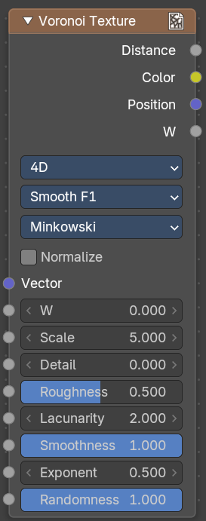
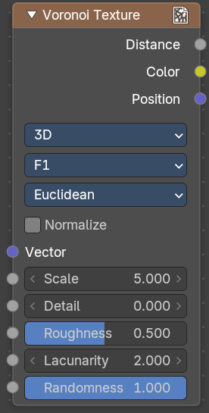
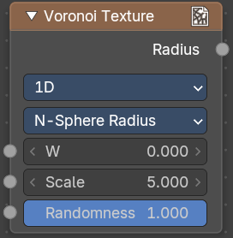

Normalize
Normalize output distance to the 0.0 to 1.0 range.

Vector
Texture coordinate to evaluate the noise at; defaults to Generated texture coordinates if the socket is left unconnected.

W
Texture coordinate to evaluate the noise at.

Scale
Scale of the noise.

Detail
The number of voronoi layers to work with.

Roughness
The influence of the previous voronoi layer to the current layer.

Lacunarity
The scale of a voronoi layer relative to the previous layer.

Smoothness
The overall smoothness.

Randomness
The randomness of the noise.

Properties

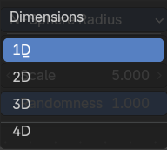
Dimensions
The dimensions of the space to evaluate the noise in.

1D
Evaluate the noise in 1D space at the input W.

2D
Evaluate the noise in 2D space at the input Vector. The Z component is ignored.

3D
Evaluate the noise in 3D space at the input Vector.

4D
Evaluate the noise in 4D space at the input Vector and the input W as the fourth dimension.

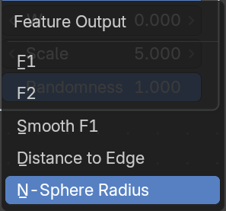
Feature Output
The Voronoi feature that the node will compute and return.

F1
Compute and return the distance to the closest feature point as well as its position and color.

Smooth F1
Compute and return a smooth version of F1.

Distance To Edge
Compute and return the distance to the edges of the Voronoi cells.

N-Sphere Radius
Compute and return the radius of the n-sphere inscribed in the Voronoi cells. In other words, it is half the distance between the closest feature point and the feature point closest to it.

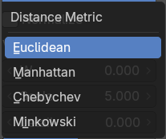
Distance Metric
The distance metric used to compute the texture.

Euclidean
Use the Euclidean distance metric.

Manhattan
Use the Manhattan distance metric.

Chebychev
Use the Chebychev distance metric.

Minkowski
Use the Minkowski distance metric. The Minkowski distance is a generalization of the aforementioned metrics with an Exponent as a parameter. Minkowski with an exponent of one is equivalent to the Manhattan distance metric. Minkowski with an exponent of two is equivalent to the Euclidean distance metric. Minkowski with an infinite exponent is equivalent to the Chebychev distance metric.

Outputs

Distance
The Distance.

Color
Cell color. The color is arbitrary.

Position
Position of feature point.

W
Position of feature point.

Radius
N-Sphere radius.
Note. In some configurations of the node, especially for low values of Randomness, rendering artifacts may occur. This happens due to the same reasons described in the Notes section in the White Noise Texture page and can be fixed in a similar manner as described there.

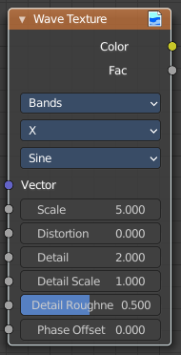
Wave Texture
The Wave Texture node adds procedural bands or rings with noise distortion.

Inputs

Vector
Texture coordinate to sample texture at; defaults to Generated texture coordinates if the socket is left unconnected.

Scale
Overall texture scale.

Distortion
Amount of distortion of the wave (similar to the Marble texture in Blender Internal).

Detail
Amount of distortion noise detail.

Detail Scale
Scale of distortion noise.

Detail Roughness
Adds a roughness noise.

Phase Offset
Set an offset for the phase.

Properties


Wave Type
Bands or Rings shaped waves.

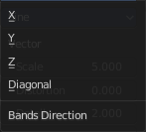
Bands direction
In which direction the bands should point.

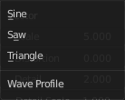
Wave Profile
Controls the shape and look of the wave type.

Saw
Uses a saw tooth profile.

Sine
Uses the standard sine profile.

Triangle
Uses a triangle shape.

Outputs

Color
Texture color output.

Factor
Texture intensity output.

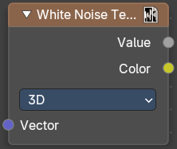
White Noise Texture
This node adds noise.

Inputs
The inputs are dynamic, they become available if needed depending on the node properties.

Vector
Vector used as seed in 2D, 3D, and 4D dimensions.

W
Value used as seed in 1D and 4D dimensions.

Properties

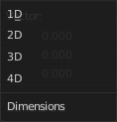
Dimensions
The dimensions of the space to evaluate the noise in.

1D
The W input is used as seed.

2D
The X and Y components of the Vector input are used as seed.

3D
The Vector input is used as seed.

4D
Both the Vector input and the W input are used as seed.

Outputs

Value
Output random value.
Note! The slightest difference in seed values would result in completely different outputs. Consequently, bad precision may have significant impact on the output. Usually, we can mitigate this issue by:
Eliminating the problematic seed value. If the problematic seed value is constant, it should be eliminated by choosing a lower dimension or multiplying it by zero.
Adding an arbitrary value to the seed. The issue might only happen at certain boundaries, like unit boundaries, so simply adding an arbitrary value might solve the issue.
Taking the absolute value of the seed. In computing, zero may be positive or negative, so taking the absolute values unifies the zero into a single value.

